**Feasibility Study**

**TECHNICAL FEASIBILITY:**

Evaluating the technical feasibility is the trickiest part of a feasibility study. This is because, at this point in time, not too many detailed design of the system, making it difficult to access issues like performance, costs on (on account of the kind of technology to be deployed) etc. A number of issues have to be considered while doing a technical

analysis.

1. **Understand the different technologies involved in the proposed system:**

Before commencing the project, we have to be very clear about what are the technologies that are to be required for the development of the new system.

1. **Find out whether the organization currently possesses the required technologies:**
   * Is the required technology available with the organization?
   * If so is the capacity sufficient?

For instance –

“Will the current printer be able to handle the new reports and forms required for the new system?”

**Operational Feasibility:**

Proposed project is beneficial only if it can be turned into information systems that will meet the organizations operating requirements. Simply stated, this test of feasibility asks if the system will work when it is developed and installed. Are there major barriers to Implementation? Here are questions that will help test the operational feasibility of a project:

Is there sufficient support for the project from management from users? If the current system is well liked and used to the extent that persons will not be able to see reasons for change, there may be resistance.

Are the current business methods acceptable to the user? If they are not, Users may welcome a change that will bring about a more operational and useful systems.

Have the user been involved in the planning and development of the project?

Early involvement reduces the chances of resistance to the system and in general and increases the likelihood of successful project.

Since the proposed system was to help reduce the hardships encountered. In the existing manual system, the new system was considered to be operational feasible.

**Economical Feasibility:**

Economical feasibility attempts 2 weigh the costs of developing and implementing a new system, against the benefits that would accrue from having the new system in place. This feasibility study gives the top management the economic justification for the new system.

A simple economic analysis which gives the actual comparison of costs and benefits are much more meaningful in this case. In addition, this proves to be a useful point of reference to compare actual costs as the project progresses. There could be various types of intangible benefits on account of automation. These could include increased customer satisfaction, improvement in product quality better decision making timeliness of information, expediting activities, improved accuracy of operations, better documentation and record keeping, faster retrieval of information, better employee morale.

**System Requirement Specification**

**Overview:**

Looking for an online shopping site to manage the items in the shop and also help customers purchase them online without having to visit the shop physically.

* Secure registration and profile management facilities for customers
* Browsing through the e-mail to see the items that are there in each category of products like Apparel, kitchen accessories, food items etc.
* Creating a shopping cart so that customer can Shoppe n no of items and checkout finally with the entire shopping cart.
* Customers should be able to mail the shop about the items they would like to see in the shop
* Updates to the customer about the recent items in the shop
* Uploading “Most Purchased” items in each category of products in the shop like Apparel, kitchen accessories, Bath accessories, food items etc.
* Strategic data and graphs for administrators and shop owners about the items that are popular in each category and age group

**Modules Description**

**No of Modules:**

The system after careful analysis has been identified to be presented with the following modules:

The Modules involved are

1. Customer
2. Employee
3. Admin
4. Security and authentication
5. Reports

**Description for Modules:**

1. **Customer:**

Customer searches the items by category wise, select the item and pay the bill. Customer takes online help from the administrator or employee. Customer check the status of the orders list

1. **Employee:**

Employees are responsible for internal affairs like processing orders, assure home delivery, getting customers delivery time feedback, updating order’s status and answering client queries online.

**3. Administrator:** Strategic data and graphs for Administrators and shop owners about the items that are popular in each category and age group. It give special discounts to premier customer.

**4. Security and authentication**:

* 1. User registration
  2. Login as user or administrator
  3. Change password
  4. Forgot password

**5.Reports**:

In this module the different actors can generate the different types of reports according to their access.

**Process Flow**

The Model 2 architecture for designing JSP pages is in reality, Model View Controller (MVC) applied to web applications. Hence the two terms can be used interchangeably in the web world. MVC originated in SmallTalk and has since made its way into Java community. Model 2 architecure and its derivatives are the cornerstones for all serious and industrial strength web applications designed in the real world. Hence it is essential for you understand this paradigm thoroughly.   
  
 The main difference between Model 1 and Model 2 is that in Model 2, a controller handles the user request instead of another JSP. The controller is implemented as a Servlet. The following steps are executed when the user submits the request.

1. The Controller Servlet handles the user’s request. (This means the hyperlink in the JSP should point to the controller servlet).
2. The Controller Servlet then instantiates appropriate JavaBeans based on the request parameters (and optionally also based on session attributes).
3. The Controller Servlet then by itself or through a controller helper communicates with the middle tier or directly to the database to fetch the required data.
4. The Controller sets the resultant JavaBeans (either same or a new one) in one of the following contexts – request, session or application.
5. The controller then dispatches the request to the next view based on the request URL.
6. The View uses the resultant JavaBeans from Step 4 to display data. Note that there is no presentation logic in the JSP. The sole function of the JSP in Model 2 architecture is to display the data from the JavaBeans set in the request, session or application scopes.   
     
     
   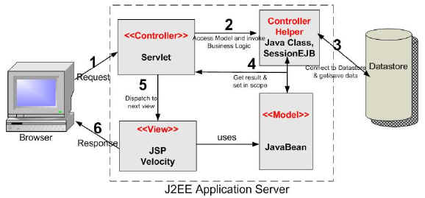

Model-2 Architecture.

**SDLC METHODOLOGIES**

This document play a vital role in the development of life cycle (SDLC) as it describes the complete requirement of the system. It means for use by developers and will be the basic during testing phase. Any changes made to the requirements in the future will have to go through formal change approval process.

SPIRAL MODEL was defined by Barry Boehm in his 1988 article, “A spiral Model of Software Development and Enhancement. This model was not the first model to discuss iterative development, but it was the first model to explain why the iteration models.

As originally envisioned, the iterations were typically 6 months to 2 years long. Each phase starts with a design goal and ends with a client reviewing the progress thus far. Analysis and engineering efforts are applied at each phase of the project, with an eye toward the end goal of the project.

The steps for Spiral Model can be generalized as follows:

* The new system requirements are defined in as much details as possible. This usually involves interviewing a number of users representing all the external or internal users and other aspects of the existing system.
* A preliminary design is created for the new system.
* A first prototype of the new system is constructed from the preliminary design. This is usually a scaled-down system, and represents an approximation of the characteristics of the final product.
* A second prototype is evolved by a fourfold procedure:

1. Evaluating the first prototype in terms of its strengths, weakness, and risks.
2. Defining the requirements of the second prototype.
3. Planning an designing the second prototype.
4. Constructing and testing the second prototype.

* At the customer option, the entire project can be aborted if the risk is deemed too great. Risk factors might involved development cost overruns, operating-cost miscalculation, or any other factor that could, in the customer’s judgment, result in a less-than-satisfactory final product.
* The existing prototype is evaluated in the same manner as was the previous prototype, and if necessary, another prototype is developed from it according to the fourfold procedure outlined above.
* The preceding steps are iterated until the customer is satisfied that the refined prototype represents the final product desired.
* The final system is constructed, based on the refined prototype.
* The final system is thoroughly evaluated and tested. Routine maintenance is carried on a continuing basis to prevent large scale failures and to minimize down time.

**The following diagram shows how a spiral model acts like:**

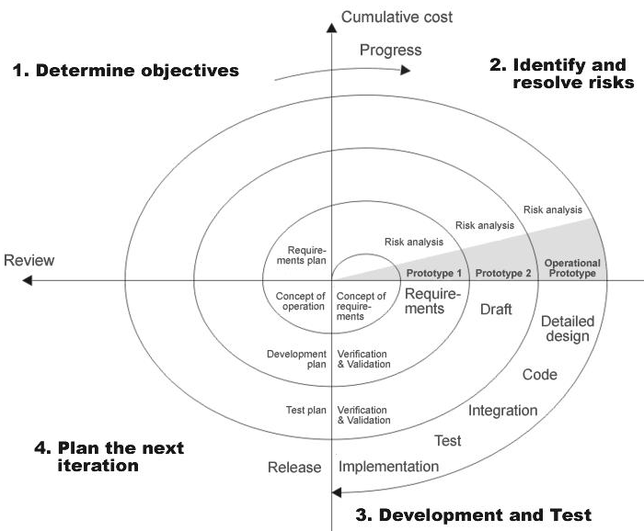

**Fig 1.0-Spiral Model**

**ADVANTAGES:**

* Estimates(i.e. budget, schedule etc .) become more relistic as work progresses, because important issues discoved earlier.
* It is more able to cope with the changes that are software development generally entails.
* Software engineers can get their hands in and start woring on the core of a project earlier.

**SOFTWARE REQUIREMENT AND**

**HARDWARE REQUIREMENT**

**Software Requirements :**

Operating System : Windows XP/2003 or Linux

User Interface : HTML, CSS

Client-side Scripting : JavaScript

Programming Language : Java

Web Applications : JDBC, Servlets, JSP

IDE/Workbench : My Eclipse 6.0

Database : Oracle 10g

Server Deployment : Tomcat 5.x

Frame Work : Struts 1.x

**Hardware Requirements:**

Processor : Pentium IV

Hard Disk : 40GB

RAM : 512MB or more